Testing and Measurements
 | Right | Left
Waist
Hip
Thigh
Calf
Upper Arm
Forearm

1 Rep Max:
Deadlift:
Bench Press:
Squat

YMCA Bench Press Test:
Pushup Test:

Step Test HR:
5K Run Time:

How to take measurements

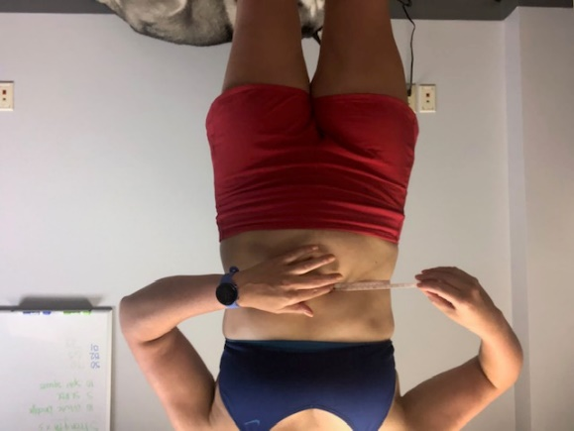
Waist Measurement: This measurement should be taken around the smallest circumference of your your stomach or waist.

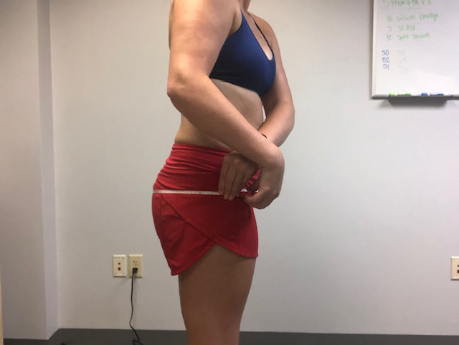
Hip Measurement: This will actually be more of a measurement of your butt. You are looking for the largest circumference around your butt for your hip measurement.

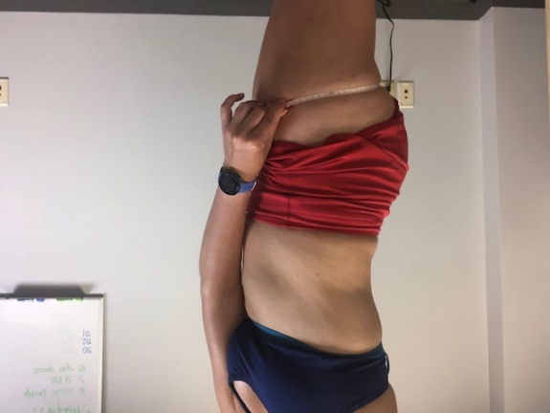
Thigh Measurement: Find the largest circumference of your thigh right under your butt. Stand with your feet apart.

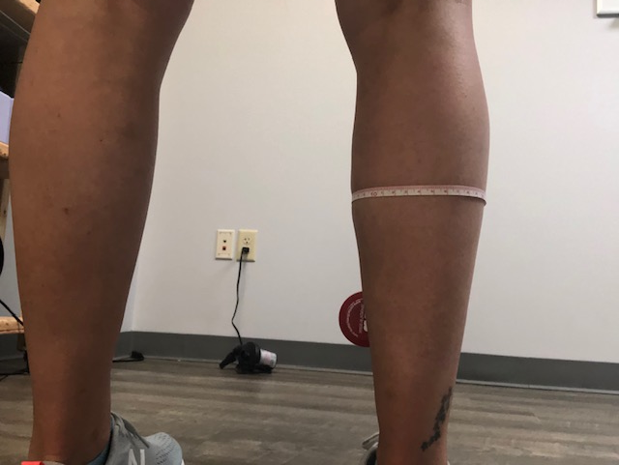
Calf Measurements: Find the largest circumference around your calf.

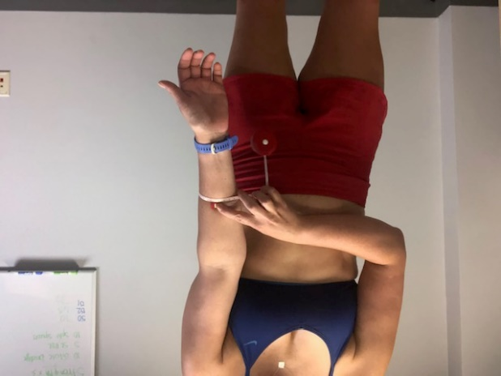
Forearm Measurements: Extend arm out and find the largest circumference of your forearm.

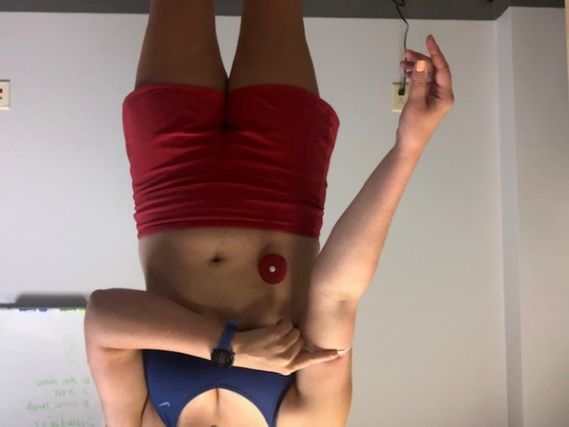
Upper Arm Measurement: Extend arm out with palm facing up and find the midpoint between your elbow and shoulder or the largest circumference around your arm.

How to Perform Test
Muscular Strength:
- Client must take the bar from the rack and lock out at top. Repeat until you have reached your 1 rep max.
1 Rep Max Bench Press:
1 Rep Max Back Squat:
1 Rep Max Deadlift:

Muscular Endurance:
YMCA Bench Press Test: Use a 35-pound barbell for Women, 80-pound barbell for men. Set the metronome to 60 beats per minute and have the client lift to the cadence. Start with the weight in the down position. Then press up and down until fatigued and cannot keep up with the cadence. Write down reps completed.
Push Up Test: Start in the down position and do pushups until fatigued or form breaks or you need more than 3 sec rest at top. If client cannot do one pushup, you can go down on to your knees. Record Reps completed

Cardio:

Queens College Step Test: You will need a step the height of 16.25in or 41.25cm (usually the size of a bleacher steps or stairs). The men will step at a cadence of 96 (all 4 steps) and women will step at a cadence of 88 beats (all 4 steps). The client will take 4 steps in the cadence for 3 minutes strait. After the 3 minutes, you will immediately take the HR of the client within 5 seconds of finishing. Then use the HR to calculate their VO2 max. Record HR when finished
Men: VO2max= 111.22 – (0.42*HR)
Women: VO2max= 65.81 – (0.1847*HR)

5K Run: Have client run a 5k for time and use this as a bench mark and have them to beat again in the assessment. Record Time took to finish.

